Exercise 7:

Draw a UML diagram for online purchasing system. Provide top level use cases for a

web customer making purchases online. Web customer actor uses some web site to

make purchases online. Top level use cases are View Items, Make Purchase and Client Register.

Aim:

To design a UML Use Case Diagram for an Online Purchasing System, illustrating interactions between a web customer and the system while browsing, purchasing, and registering.

Procedure:

Step 1: Identify Key Actors

Web Customer – Uses the website to make purchases.

Online Store System – Manages items, purchases, and user registration.

Payment System – Handles online transactions.

Step 2: Define Use Cases for Each Actor

Web Customer

View Items – Browse the available products.

Make Purchase – Buy selected products.

Client Register – Register as a new user.

Online Store System (Internal Use Cases)

Manage Items – Maintain product catalog.

Process Order – Handle order details and confirm purchase.

Authenticate User – Verify customer identity during login or registration.

Payment System

Process Payment – Handle transactions securely.

Step 3: UML Use Case Diagram Components

Actors: Web Customer, Online Store System, Payment System.

Use Cases: View Items, Make Purchase, Client Register, Process Payment, Manage Items, Authenticate User.

Relationships:

Web Customer interacts with View Items, Make Purchase, and Client Register.

Make Purchase includes Process Payment.

Client Register extends Authenticate User.

Online Store System manages the catalog and processes orders.

Output:

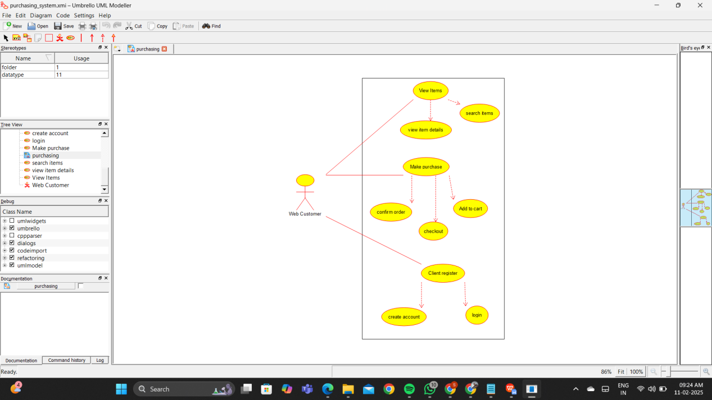

Result:

Thus the UML diagram has been implemented successfully.